Zonta Club of Glens Falls
Contact: President Karen Hartman, ksullihart@gmail.com, 518-744-9608

New Z Club of the North Country Chartered

The Zonta Club of Glens Falls announces the charter of a new club for teens, The Z Club of the North Country. Charter members, Arabelle Barnaby-Wood, Queensbury High School Senior, and Jessica Barnes, Saratoga Central Catholic School Senior, were installed as Co-Presidents at the Zonta Club of Glens Falls Holiday Dinner held on December 13, 2022, at The Log Jam Restaurant, Lake George.

The Z Club of the North Country, sponsored by the Zonta Club of Glens Falls, is one of 298 Z Clubs Worldwide. Zonta International encourages young people to prepare to assume roles of responsibility and leadership in the world. Through the opportunities Zonta International provides, it is the hope that Z Club members will strive to promote fellowship and understanding among all people of the world.

The Z Club program was initiated in 1948 by Zonta International and is part of Zonta International’s service projects. Zontians work to bring Zonta International’s mission, to empower women through service and advocacy, to students worldwide and to stimulate new student-led service and advocacy projects. The youth of today will be the leaders of tomorrow and the Zonta International Z Club program is a way for these future leaders to build a better world for women and girls.

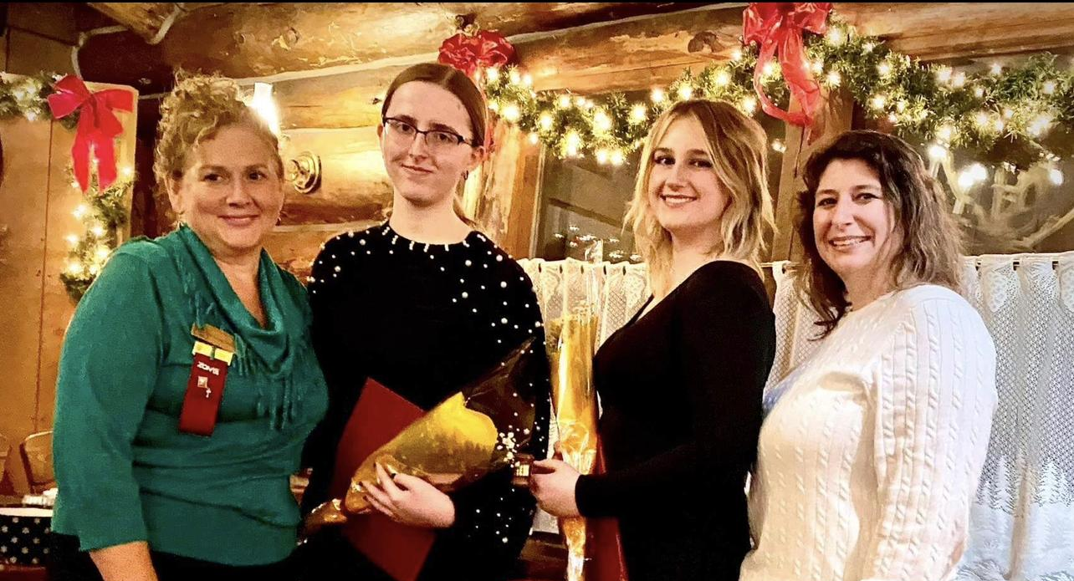
High School students interested in exploring Z Club of the North Country membership can contact co-advisors, Stacey Wood and Karen Hartman at zclubofthenorthcountry@gmail.com and visit the club’s Facebook page “Z Club of the North Country”.

Pictured - Karen Hartman, Zonta Club of Glens Falls President, Jessica Barnes, Arabelle Barnaby-Wood, Stacey Wood, Z Club of the North Country Advisor

